Problem 1
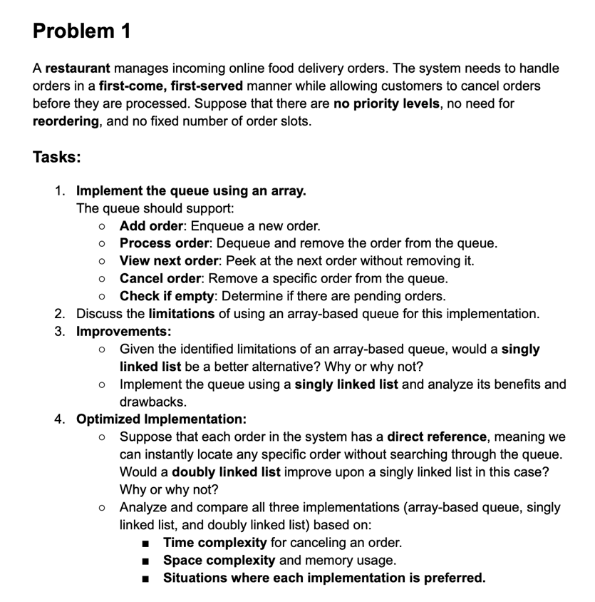
Insert Task 1 python code:
Task 2:
Discuss the limitations of using an array-based queue for this implementation.
An array based queue has some limitations:
To remove an order from the middle of the queue, it requires O(n) time complexity, as it has to loop through the array untill it finds the correct element. It then has to shift all elements after it.
When an order is dequeued from the front, all elements still need to be shifted forwards, requiring O(n) time complexity, instead of O(1).
As python arrays dynamically change size, sometimes when adding an element to the back of the queue, the current array size reaches capacity, so python creates a new array double the size and copies all elements across which requires O(n) time. Otherwise, adding an elemnt to the back of the queue should usually be O(1) time.

Task 3:
Given the identified limitations of an array-based queue, would a singly linked list be a better alternative? Why or why not?
Dequing an element from the front can be done in O(1) time, rather then O(n)
Enqueueing an element to the back will always be in constant time (O(1)).
A linked list dynamically allocates memory unlike an array that needs to resize which prevents unnecessary memory usage.
However there are still some drawbacks.
Cancelling an order from the middle of the queue is still O(n) as we still need to search through the que to find the element
Each node in a linked list also requires memory for storage of a pointer to the next node, thus is less space efficient then an array.
Overall, a singly linked list is better then an array based queue if there are frequent enqueue and dequeue operations mainly due to not needing to shift all elements. However order cancellation time is still not improved and it also uses more memory due to the need to store pointers for each node.
Insert Task 3 python code:
Task 4:
Suppose that each order in the system has a direct reference, meaning we can instantly locate any specific order without searching through the queue. Would a doubly linked list improve upon a singly linked list in this case? Why or why not?
Yes a doubly linked list would improve performance for order cancellation. This is because it changes this operation to constant time O(1), rather then O(n) like it is in an array or singly linked list. The reason for this is that each order now has a direct reference and therefore we do not have to traverse the array to find it. However, a doubly linked list will require more memoruy usage as each node stores an extra pointer to its previous element.
Analyze and compare all three implementations (array-based queue, singly linked list, and doubly linked list) based on:
- Time complexity for canceling an order.
- Space complexity and memory usage.
- Situations where each implementation is preferred

Time complexity:
Array: O(n) as it has to search for the element and then shift all elemnts after it.
Singly Linked List: O(n) as it requires traversal through the list.
Doubly Linked List: O(1) as there is a direct reference to the order so no traversal is required.
Space complexity:
Array: O(n), This is the most memory efficient as there are no extra pointers stored, the only drawback is the dynamically changing array sizes which can be sometimes over allocated.
Singly Linked List: O(n), This is the second most efficient as it requires storage of a pointer for each node, there is no over allocation however.
Doubly Linked List: O(n), This is the least memory efficiend as it requires storage of two pointers for each node, using the most memory per order, there is no over allocation however.
An array based queue implementation is best used in a situation where memory is very limited and order cancellations are rare. A singly linked list is best used when orders are frequently being added and dequed. A doubly linked list is best used when orders within the middle of the queue need to cancelled frequently and each order has a direct reference.

